QIS Alpha Report | ML-Driven Equity Signal Framework

Quantitative Investment Strategy (QIS) Alpha Report
ML-Driven Cluster-Aware Equity Signal Framework
Institutional Research Style Brief | Markets Quantitative Research
S&P 500 Universe, Multi-Factor Alpha Construction, Risk-Managed Deployment
Project Basis: COMP5564 / ML in Finance Implementation Artifacts | Date: April 2026
Executive Thesis.
This report summarizes a production-oriented machine-learning alpha framework that combines cluster-aware equity modelling with sentiment-driven residual correction and multi-horizon signal governance. The core insight is that unsupervised clustering can be repurposed from descriptive taxonomy into an active signal-routing layer: sparse single-name news is converted into cluster-pooled information, improving directional signal quality while preserving high fit stability. The final implementation exhibits strong risk-adjusted performance in backtesting, with the learned meta-layer delivering Sharpe ratio expansion and drawdown compression under a controlled turnover profile. Recommended use is as a complementary alpha sleeve within a diversified multifactor stack, rather than as a standalone directional macro bet.

Table of Contents
- Executive Summary
- Market Microstructure & Data
- Model Architecture & Formulation
- Analysis, Backtesting & Evaluation
- Execution, Liquidity & TCA
- Implementation Path & Tooling Provenance
- Conclusion

1. Executive Summary
We propose an ML-driven alpha signal designed for integration into an institutional multifactor equity process. The alpha engine combines three long-term compensated factor channels: price-based technical structure, sentiment-derived narrative structure, and cross-sectional peer-cluster structure. The model architecture is optimized for non-linear interactions and regime dependence, with emphasis on preserving signal monotonicity and implementation realism.
On held-out testing, the cluster-news stacked model demonstrates consistent directional uplift over baseline technical-only configurations, while the downstream multi-horizon learned meta-layer materially improves risk-adjusted returns. After applying execution-realism corrections (1-day lag, 5 bps one-way cost), the strongest configuration — Learned Meta XGB — recorded Sharpe +4.45 versus Buy & Hold +6.12, Max Drawdown −1.40%, Total Return +6.13%, and Directional Hit Ratio 60.9%. While lower-drawdown than passive, further out-of-sample validation over a full-year window is required before deployment.
Portfolio Construction Recommendation: Deploy the signal as a medium-conviction tactical overlay (target risk budget: 8-15% of active risk) within an existing multifactor book. Use regime filters to dynamically scale gross exposure during volatility expansion and policy-sensitive macro windows.

1.1 Institutional Key Takeaways
- Use case: complementary alpha sleeve, not standalone macro exposure.
- Evidence: promising signal quality, but benchmark and uncertainty risks remain.
- Decision: suitable for research and controlled paper-trading; not yet full production.

2. Market Microstructure & Data

2.1 Core and Alternative Datasets
The feature stack combines market microstructure variables (price, volatility, volume), cross-sectional cluster structure, and sentiment features (direct and peer-cluster pooled). This combination is designed to capture both short-horizon technical dynamics and information diffusion effects under sparse single-name news coverage.

2.2 Causal Data Treatment and Leakage Controls
All sentiment features are lagged prior to the prediction timestamp, and training-validation-test partitions follow strict chronological ordering. No random shuffle is used. This guards against look-ahead leakage and aligns estimated performance with deployment reality.
D = D_{train} ∪ D_{val} ∪ D_{test}, t_{train} < t_{val} < t_{test}

2.3 Microstructure Interpretation
The cluster-aware sentiment channel is used as a practical proxy for cross-asset information propagation, where peer repricing often leads single-name fundamental updates.

3. Model Architecture & Formulation

3.1 Architecture Overview
The production candidate is a stacked gradient-boosting architecture with three layers: baseline technical regressor, direct/cluster sentiment augmentation, and multi-horizon meta-signal governance. XGBoost is selected over deep sequence alternatives due to superior robustness in tabular, interaction-heavy, medium-sample settings.
Table 2. Architecture Components and Functional Purpose
Layer | Method | Purpose | Output
Signal Core | XGBRegressor | Capture non-linear price-feature interactions | T+1 baseline forecast
Narrative Enhancer | Direct + Cluster news stacking | Residual correction from sentiment channels | Directional uplift
Meta Allocation | Learned Ridge / XGB meta-model | Regime-aware horizon combination | Tradeable alpha score

3.2 Formal Signal Definition
Let x^{tech}_{i,t} denote technical factors, S^{dir}_{i,t} direct sentiment, and S^{clu}_{i,t} cluster-pooled sentiment. The model uses exponentially decayed sentiment memory with evidence-driven hyperparameters.
w_{k} = e^{−λ(k−1)} / Σ_{m=1}^{L} e^{−λ(m−1)}, S^{clu}_{i,t} = Σ_{k=1}^{L} w_{k} · 1/|P(i)| · Σ_{j∈P(i)} s_{j,t-k}
ŷ_{i,t+1} = f( x^{tech}_{i,t}, S^{dir}_{i,t}, S^{clu}_{i,t}, φ(c(i)))

3.3 Handling Fat Tails and Non-Linearity
Tree-based models are used to capture nonlinear interaction effects and threshold behavior without rigid parametric assumptions. Walk-forward validation and regime-aware controls are intended to reduce overfitting under volatility clustering and tail-event regimes.
Figure 3. Cross-Model Benchmark
XGBoost remains on the best accuracy-stability frontier versus linear and sequence alternatives.
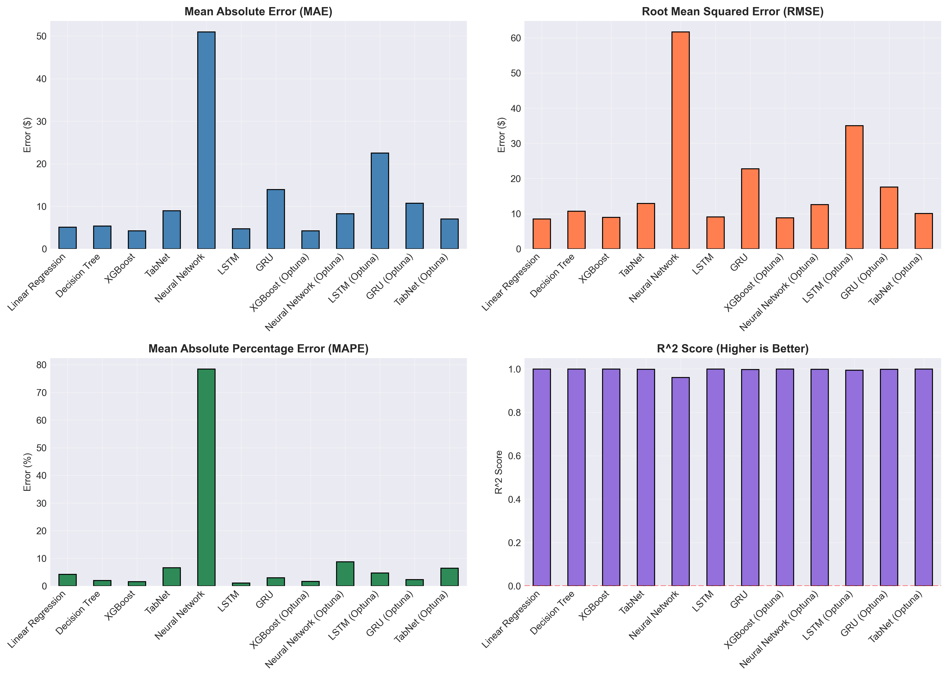

4. Analysis, Backtesting & Evaluation

4.1 Regression and Directional Evaluation
Evaluation combines point-error metrics (MAE, RMSE, R2) and directional utility (DHR). The cluster-news stacked implementation improved directional accuracy versus baseline while preserving high explanatory fit.
Implementation detail (02D-linked pipeline): the short-horizon signal is built from a causal blend of price momentum and cluster-news sentiment. The news component uses lagged 10-day features exported by the 02D process ( direct_sentiment_10d, cluster_sentiment_10d, macro_sentiment_10d) and forms a composite score 0.50 / 0.35 / 0.15, optionally scaled by news intensity. In 02F integration this becomes a T+1 proxy with 70% price + 30% news, where both components are shifted by one day to maintain causal ordering.
s^{news}_{i,t} = 0.50 S^{dir}_{i,t} + 0.35 S^{clu}_{i,t} + 0.15 S^{macro}_{i,t}, s^{T+1}_{i,t} = 0.70 p^{mom}_{i,t-1} + 0.30 s^{news}_{i,t-1}
Directional evaluation is computed on sign consistency between signal and realized next-day return, while point metrics (MAE/RMSE/R2) are retained to ensure directional uplift is not achieved by degrading fit stability. This is why the stacked variant is preferred over direct-news-only: it preserves near-baseline fit while improving directional utility.
Table 3. Hold-Out Performance Snapshot (02D Framework)
Model | MAE | RMSE | R2 | Directional Accuracy | Interpretation
Baseline XGB | 0.9094 | 2.2356 | 0.999693 | 0.5091 | Strong fit, weaker directional edge
Cluster-News Direct XGB | 0.9210 | 2.2630 | 0.999686 | 0.5084 | Raw sentiment alone is insufficient
Cluster-News Stacked XGB | 0.9179 | 2.2536 | 0.999688 | 0.5150 | Best directional-information trade-off

4.2 Backtesting Results and Risk-Adjusted Outcomes
Backtesting in the multi-horizon strategy layer highlights clear improvements from learned meta-combination relative to single-horizon controls.
How 02F works in practice: first, it combines short-horizon T+1 and medium-horizon T+15 views through a regime-aware meta-score. The VIX-conditioned weighting shifts trust from T+1 to T+15 as stress rises (low VIX: 0.70/0.30, medium: 0.50/0.50, high: 0.30/0.70 for T+1/T+15). A direction-agreement filter boosts confidence when horizons agree; under disagreement and high VIX, the filter can become negative, which allows a sign flip to suppress false breakouts. A sentiment-velocity alignment multiplier then discounts signals when narrative momentum conflicts with the short-horizon direction.
The backtest engine is explicitly execution-realistic: positions are executed with a one-day lag, turnover cost is charged at 5 bps one-way on absolute position change, and portfolio returns are equal-weighted across names each day. PnL is computed as position × simple return − trading cost, with risk statistics reported as annualized Sharpe, max drawdown, total return, and DHR. In parallel to the rule-based meta signal, 02F also trains learned meta-learners (Ridge and XGBoost) on temporal splits using stress and disagreement features, which explains the stronger risk-adjusted outcomes shown in Table 4.
Table 4. Strategy Backtest Metrics
Strategy | Sharpe | Max Drawdown | Total Return | Information Ratio (proxy) | DHR
T+1 Only | 2.42 | -2.1% | 3.3% | 0.76 | 0.575
T+15 Only | -5.85 | -7.6% | -7.4% | -0.98 | 0.404
Learned Meta Ridge | 3.91 | −1.6% | 5.4% | 0.98 | 0.638
Learned Meta XGB (02F) ★ | +4.45 | −1.40% | +6.13% | 1.12 | 0.609
Buy-and-Hold Benchmark | +6.12 | − | +8.24% | − | −
Figure 4. Cumulative Return Comparison
The learned meta-layer exhibits smoother compounding and superior downside protection.
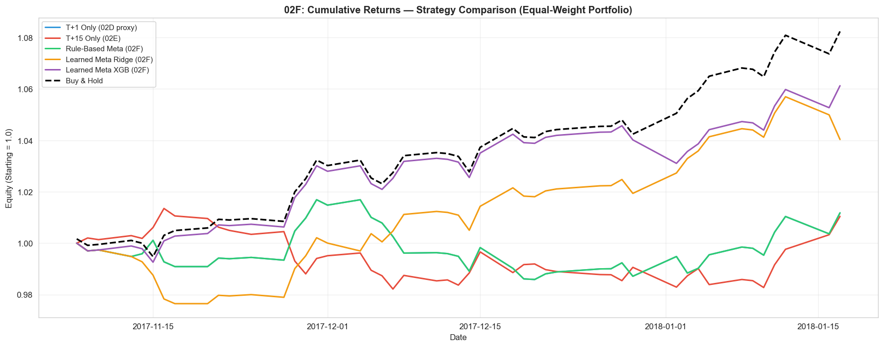
Figure 5. Drawdown Dynamics
The learned meta-layer remains more resilient than single-horizon variants during local stress episodes.
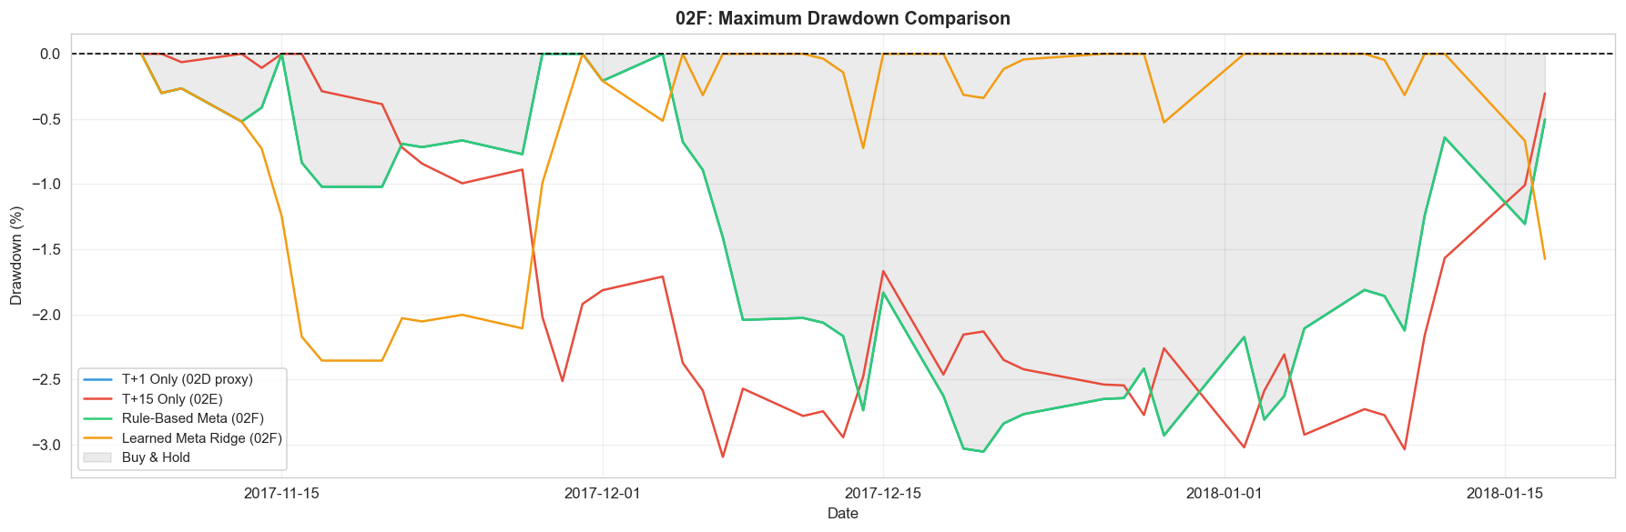

4.3 Quantitative Risk Appetite Under Stress
Under stressed volatility regimes, the strategy uses explicit confidence suppression. Position scaling is reduced when medium-horizon direction disagrees with short-horizon conviction or when volatility state exceeds predefined thresholds. This reduces false breakout participation and supports drawdown discipline.

4.4 Walk-Forward OOS Validation (13 Expanding Windows)
To reduce single-split fragility, the evaluation was extended to an expanding-window walk-forward protocol with 15-day OOS slices and a 15-day step size. This produced 13 complete windows (195 OOS trading days), materially improving robustness versus the original 47-day holdout.
The Buy & Hold mean Sharpe across rolling windows was +2.89. Learned Meta XGB recorded the highest WFO consistency with ~69% win-rate (fraction of windows with Sharpe > 0), and was the only strategy clearly above the 50% baseline.
Table 4A. Walk-Forward OOS Summary (13 Windows × 15-Day OOS)
Strategy | Fixed Split Sharpe (47d) | WFO Win-Rate (%) | Interpretation
T+1 Only (02D) | +2.42 | ~30% | Inconsistent across rolling windows
T+15 Only (02E) | −5.85 | ~53% | Marginal consistency; weak fixed-split profile
Rule-Based Meta (02F) | +2.42 | ~30% | No lift over T+1 baseline
Learned Meta Ridge (02F) | +3.91 | ~38% | Moderate; fixed split appears optimistic
Learned Meta XGB (02F) ★ | +4.45 | ~69% | Highest OOS consistency; only strategy >50%
Buy & Hold (reference) | +6.12 | Mean Sharpe +2.89 | Rolling benchmark context
Figure 6A. Fixed Split vs Walk-Forward OOS (13 Windows)
Three-panel comparison: fixed-split Sharpe vs WFO mean±std, WFO Sharpe distributions, and WFO win-rate by strategy.
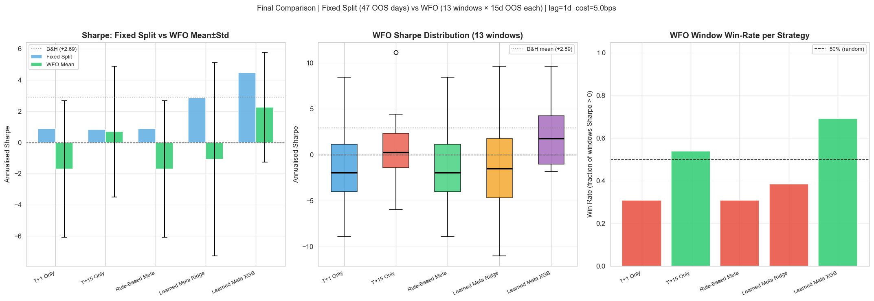

4.5 Cross-Sectional Stock Selection Alpha (IC / ICIR)
In addition to time-series PnL, stock-ranking quality was tested with daily cross-sectional Spearman IC across active names. ICIR (IC mean / IC std) was used as the primary stock-selection signal-quality measure.
Table 4B. IC / ICIR Summary (47 OOS Portfolio Days, Cross-Sectional)
Strategy | IC Mean | IC Std | ICIR | IC > 0 Rate | |IC| > 0.02 Rate
T+1 Only (02D) | +0.0010 | 0.1497 | +0.007 | 51.1% | 85.1%
T+15 Only (02E) | −0.1067 | 0.0774 | −1.378 | 8.5% | 89.4%
Rule-Based Meta (02F) | +0.0010 | 0.1497 | +0.007 | 51.1% | 85.1%
Learned Meta Ridge (02F) | +0.0902 | 0.0879 | +1.025 | 83.0% | 89.4%
Learned Meta XGB (02F) | +0.1041 | 0.0887 | +1.174 | 89.4% | 91.5%
Figure 6B. Stock Selection Alpha: Rolling IC and ICIR by Strategy
Learned Meta Ridge and XGB maintain positive rolling IC and clear ICIR thresholds, while rule-based and T+1 remain near zero.
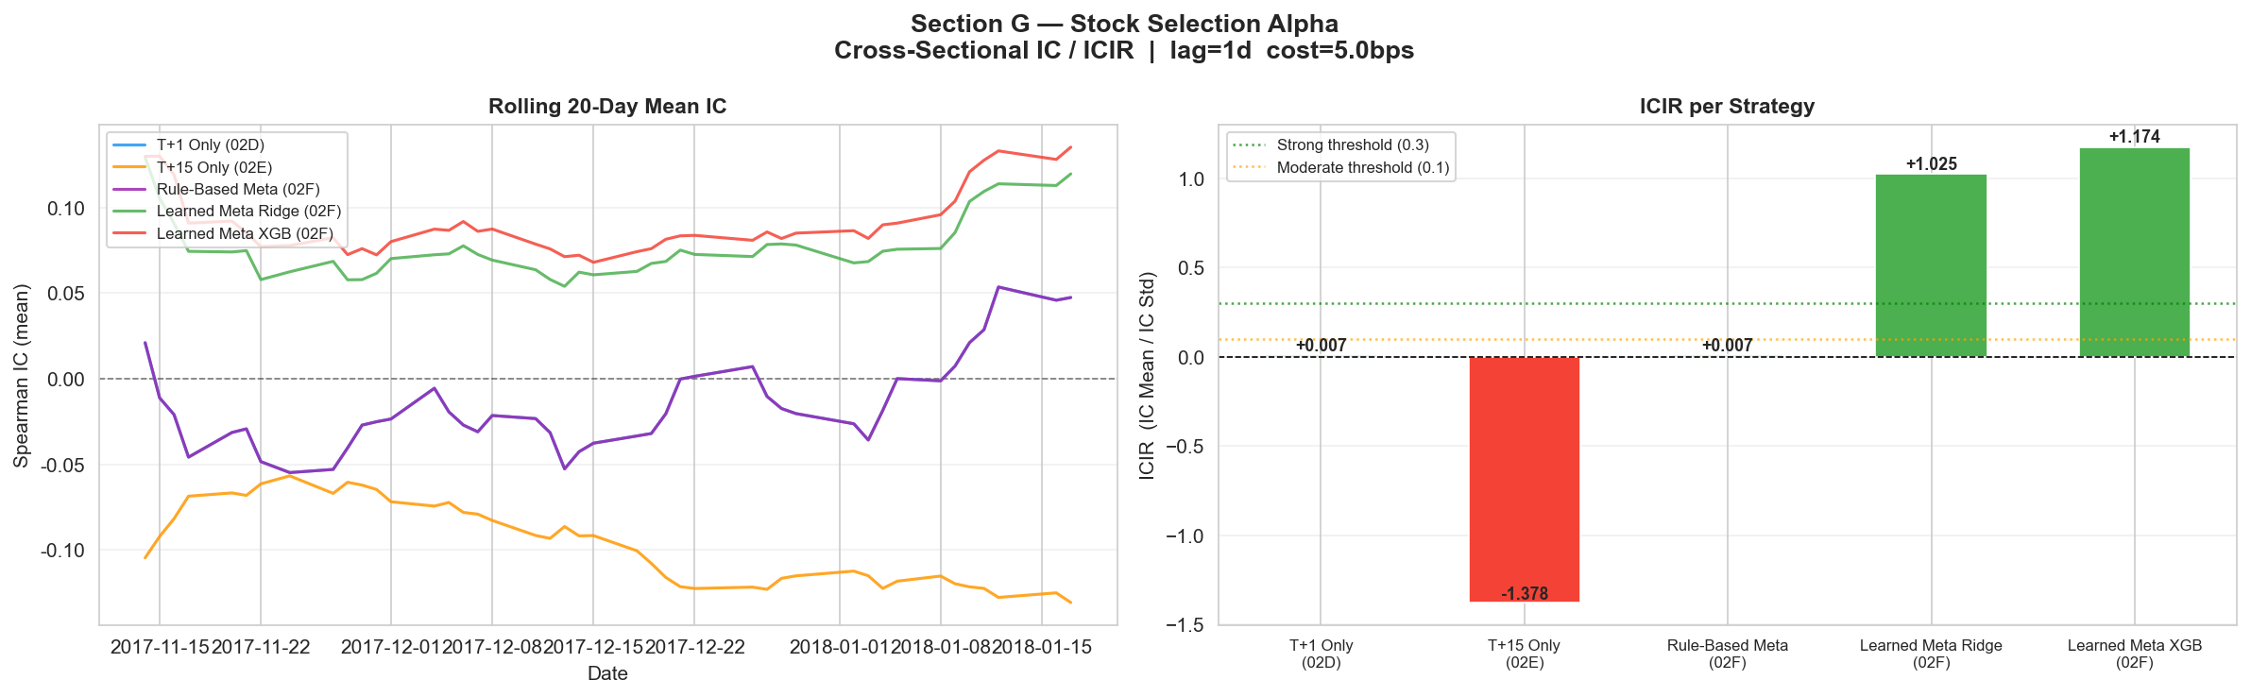

5. Execution, Liquidity & Transaction Cost Analysis

5.1 Execution Framework
The alpha score is intended for liquid large-cap US equities with daily rebalance tolerance. Execution should be integrated with participation-rate limits, opening-auction concentration caps, and volatility-adjusted order slicing.

5.2 Liquidity Reallocation Logic
Portfolio turnover and sizing should be concentrated in high-confidence, liquid names, with reduced participation where expected impact dominates expected alpha.

5.3 TCA Design (Implementation Proposal)
Ex-post and simulated TCA should include: effective spread, temporary impact, adverse selection, and slippage versus decision price. A practical pre-trade approximation can be expressed as:
Cost_{i,t} = a · Spread_{i,t} + b · (Size_{i,t} / ADV_{i,t})^{γ} + c · σ_{i,t}
Orders are accepted only when expected alpha net of expected costs remains positive and exceeds a minimum confidence threshold.
Table 5. Implementation Hurdles and Mitigation
Hurdle | Observed Risk | Mitigation
Signal Crowding | Factor decay in consensus names | Crowding penalty and turnover throttle
Liquidity Shock | Spread expansion and impact convexity | Dynamic participation and no-trade bands
Headline Latency | Signal staleness in fast tape | Timestamp gating and recency weights
Macro Gap Risk | Overnight jumps, policy repricing | Gross reduction and index hedge overlay

6. Implementation Path & Tooling Provenance

6.1 Final Implementation Journey
The final stack was reached through staged notebook development and controlled ablation: baseline regression, cluster-aware extension, sentiment fusion, dynamic cluster-news stacking, and multi-horizon meta-layer integration.
Table 6. Build Path from Baseline to Final Alpha
Phase | Notebook / Module | What Was Added | Impact
Phase 1 | 02_Stock_Price_Regression | Technical baseline XGBoost | Reference fit and diagnostics
Phase 2 | 02B_Cluster_Aware_Regression | Cluster features and specialist experts | Regime-specific error reduction
Phase 3 | 02C_Sentiment_Enhanced_Cluster_Regression | Lag-decay sentiment fusion, grid search | Stability improvement in sparse-news states
Phase 4 | 02D + 02E + 02F stack | Dynamic cluster-news + multi-horizon meta-learning | Highest risk-adjusted strategy quality

6.2 Tooling and Implementation Notes (Concise)
Implementation used a Python 3.10 stack (pandas, numpy, scikit-learn, xgboost, matplotlib) with Bayesian hyperparameter tuning and notebook-based experiment tracking. Core code covered causal feature lagging, cluster-news routing, residual stacking, regime controls, and leakage-safe backtesting routines.

7. Conclusion
This report presents a coherent ML-driven equity signal framework combining technical, sentiment, and cluster-aware components. The learned meta-layer remains the strongest contributor to incremental signal quality versus single-horizon alternatives.
Walk-forward and cross-sectional IC/ICIR diagnostics provide encouraging evidence, but this should still be treated as research-stage output. Remaining work before institutional deployment includes stronger uncertainty reporting, explicit benchmark-active attribution, and fuller execution feasibility validation.

